My Girlfriend’s Back and There’s Gonna Be Trouble

An unproduced H&McC by Karen Klein dated June 14, 1984

The episode opens with the guys enroute home from a fishing trip, exchanging quips as they stop at a roadside diner.

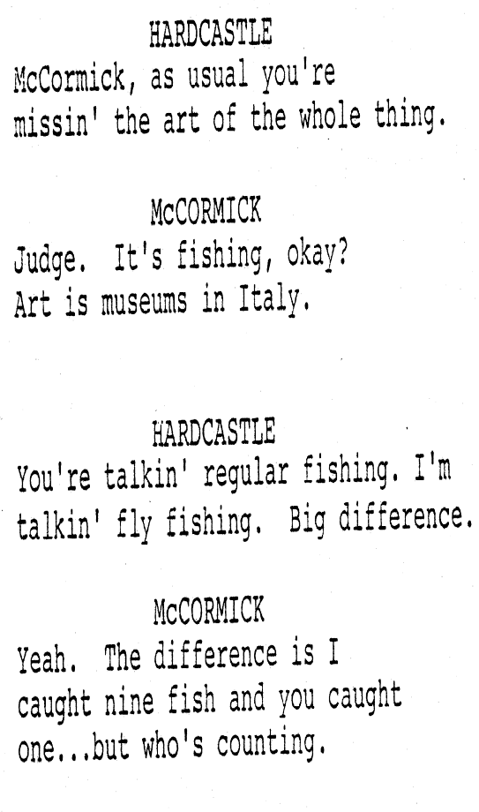

In the diner, Hardcastle runs into an old flame, the former Marian Gable, now working under an assumed name as a waitress. She takes off; the judge grabs Mark and pursues. When they finally catch up, Milt and Marian have a heated exchange in which we (and Mark) learn that they were a serious item only two years earlier (the judge even proposed to her). She ducked without an explanation and left no forwarding address. Their tense exchange ends with her promising to meet him again that night and explain everything.

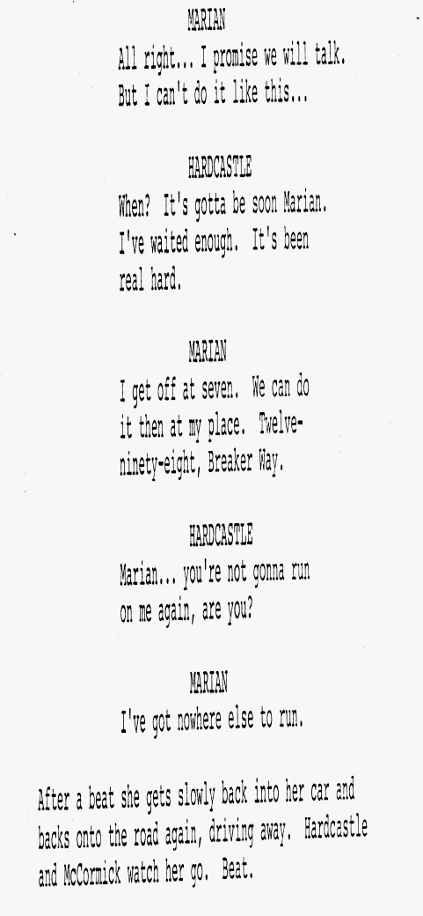

A little later, back at Gull’s Way, Hardcastle is busy grilling up some trout. He tells McCormick what happened in the first half of the movie—how he met Marian (helping her out with some legalese regarding some orphans), and how much she loved grilled trout. He’s self-conscious about the whole matter and Mark jibes him just a little about how he though he was the lone wolf type, but on the whole is pretty understanding.

Eventually the judge wraps the little pop-eyed fishies up and takes them over to the address Marian gave him—only to find the place is under siege by the police and Marian is being carted off on a murder rap by a detective named Keller.

In the next scene, Milt is camped in the hallway outside Lt. Delaney’s office. Mark shows up.

Delaney finally provides him with a file. The evidence (including the murder weapon found in Marian’s apartment) seems damning. Marian is the only suspect in the murder of Eric Boston—the son of mobster Jimmy Boston. The crime occurred six years earlier and the cops have been trailing her ever since.

In the next scene we meet the Boston family. Jimmy, the aged father, appears to have mellowed some. He’s hanging out in a garage with a working-stiff cousin. Nick, the unloved, hot-head eldest son, shows up with the news that his middle-brother’s murderer has been arrested. He wants to have her killed.

His father tells him to let the law take care of things. He also implied that his dead middle-son was his favorite, and though he’s gone, Nick still hasn’t moved up in the ranks; there’s an even younger son who’s coming home from college soon. Nick is peeved. He thinks he’s been running things just fine and resents the plans to have his kid brother take over.

Meanwhile, back at the station, Milt and Marian have a heart-to-heart about the murder. She says Nick killed Eric. She says she was with Eric’s chauffer, a man named Jody Rice.

Back at his office, Nick’s discussing things with his consigliere, Don Holland. He’s worried that Marian will get someone to believe he murdered Eric. He also has an informant in the LAPD and knows that Hardcastle is involved. They have . . . a plan.

Next, it’s the arraignment. Milt is there with Marian. A lawyer named Jerry Blotnik shows up, saying he’s been assigned as Marian’s P.D. Hardcastle doesn’t like the looks of him and suspects he’s on Nick’s payroll. He dismisses him and announces he’s Marian’s counsel.

Next we see Milt and Mark with a sleazy bail bondsman, Mario California, who’s telling Milt that Marian’s bond is going to cost him big.

They part from Mario on that cheerful note. Mark reluctantly points out that Mario is right—Marian is high-risk, and while Hardcastle’s money is his to do with as he wishes, his motives on this go-round are a little hazy. The little exchange is so good I just have to paste the whole thing in:

Wait a sec, Milt just asked Mark to be his very own Jiminy Cricket? Yup.

Mark agrees, reluctantly. He also predicts Milt isn’t going to be very happy with the arrangement.

Back to the ranch again—this time with the bailed-out Marian. The three discuss the case. No shot was heard—and how dangerous is Nick?—another mention of the alibi chauffer. Yadda, yadda. Lots of foreshadowing. Hardcastle departs to see an informant.

His name is Richard Truly, which gives the judge a chance to utter the line:

The discussion continues. The two agree that Nick Boston is nuts, or (in the words of Mr. Truly) “If you cured him he’d be nuts.” He provides further stories of Nick’s short fuse and tendency to act without thinking things through.

Next scene: Mark and Milt in the Coyote buzzing over to visit Nick at his home. Very reasonably, Mark questions Milt’s sanity, poking a known psychopathic mobster:

Mark tries to invoke his new responsibilities and authority as Hardcastle’s “conscience”:

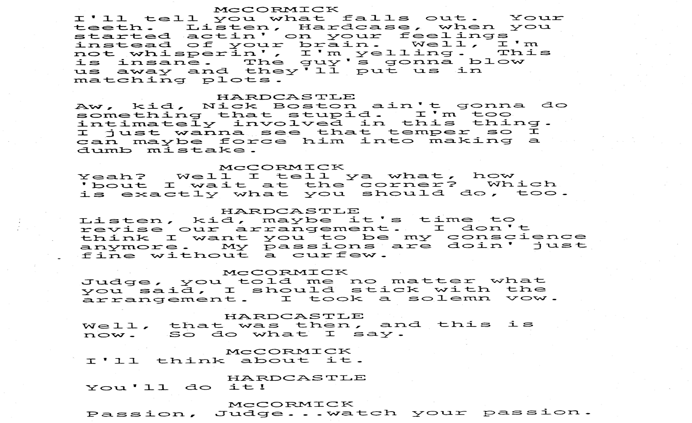

Next, Hardcastle eggs Nick on in the man’s own driveway—but it’s Mark who ratchets things up a notch:

Hardcastle takes advantage of the tiff that follows to toss Nick a subpoena.

That night, at the estate, intruders sneak into the gatehouse (Marians’s staying there. Where’s Mark staying? Dunno.). They’re caught shooting up the bed which she’s fortunately not sleeping in.

Cut to the next day—Hardcastle goes to interview a guy in a steam bath. On the night of the murder he was staying in the hotel room next to the one Eric occupied. He heard no shots. (I think we got that part now.)

Moving right along (page 44 of a 69 page script), its Hardy Boys time, back at the estate. Milt’s got a water barrel and a pistol and he’s doing some forensic science stuff here. Mark rightly points out that the LAPD has a regular evidence lab and everything. Milt has Mark retrieve his spent bullets and says he’s going to get his microscope, for mercy’s sake.

Luckily, before we get to that scene, Delaney calls to remind the guys that this is an action show. Oh, and there’s some bad news about the chauffer, Jody Rice.

Back at Jimmy Boston’s study, Nick and Don (the consigliere) have been called to a meeting by Nick’s dad. Before Jimmy walks in, the other two are discussing a guy named Michael Rigby, who needs to be found and killed.

Jimmy finally walks in. Long story short, dad’s mad about the attempted hit on Marian. Nick’s being demoted; Don’s in charge.

Brief interlude at Gull’sWay. (and another foreshadowing alert) Marian is talking about her sister and family—she (Marian) wanted a bunch of kids (leading us to wonder just how May-Dec was this romance between Milt and Marian?). But, anyway, the bloom is off the rose. Milt is steamed. He tells Marian that Jody Rice was in prison the year Eric was killed.

Marian confesses (new version). The chauffer wasn’t Rice; it was Michael Rigby. He protected her (out of love), and that’s why she didn’t use his name.

Next we have Milt and Mark with squad cars rushing to an apartment building, pool-hall on first floor. Big action scene because Nick’s assassins got there first but hadn’t left yet. Alas, too late. Rigby’s dead.

Last act: it opens in a courtroom. Really. Hardcastle being the attorney of record in a trial. Cool, huh? He’s questioning a police lab guy about the murder weapon and the fatal bullets. He’s hammering home the point that the bullet shows signs of having been fired through a silencer (a suppressor, for you purists) but that only the gun was found with the weapon in Marian’s apartment.

Then he asks for a recess of two hours so he can produce some important material evidence. Sounds hinky to me,. Sounds hinky to the DA, too, but the judge (the real one, no the ex-one) says ‘okay’.

Nick and his father were in the courtroom during all this. Nick, being a dolt, rushes out of the courtroom to incriminate himself. The police are in place to follow him. Mark is already at Nicky’s home, out of sight. Bug reveal: Nick goes straight to the secret silencer stash and retrieves it. As he steps out of the house, with goon and people’s exhibit #28, Mark confronts him.

Snappy commentary, big fight, scramble for the evidence, Nicky fleeing in a car with Mark clinging to the hood—all that. Milt and cops arrive and chase ensues. In the big finish, though, it’s Nick’s dad who corners Nick’s car with his own.

Epilogue: At Gulls Way it’s more trout on the grill. Marian is the guest of honor. She finally reveals that she can barely stomach trout. She only ate it all those times to be polite. There’s a metaphor here, it seems.

And of course we saw this coming:

