

On the recommendations of the faculty,
and by virtue of the authority invested in them,
the trustees have conferred upon

Milton C. Hardcastle

the degree of



And have granted this diploma as evidence thereof
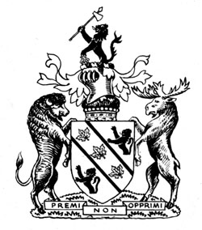
on this day, June 10th 1954,
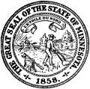
in the City of Frostbite Falls, Minnesota


